4
PREP  - Safety Procedures:  - Work in PCR Box or BSC  - Designated CLEAN Lab coat, gloves, face mask, and face shield/goggles  - Wipe down all work surfaces, tube racks, and all items used with 10% bleach solution followed by ethanol (as needed)  - Turn on UV lamp for 15 minutes in PCR Box or BSC (at start or end of prev run)  - Check to ensure you have sufficient amounts of all materials for number of lots to be created (Calculator)  - With Scale (USSolid1), measure 28.2mL of NF Water in 50mL Falcon Tube, leave in the refrigerator > 1hr (prep ahead).  - Ensure Primer Resuspension NF Water is also in refrigerator > 1 hr (prep ahead).  - Do Startup of the Opentrons (last page).  - Load Opentrons software, open protocol “iPGS48_x68_SOP-201-B_2.json”  MAKE PGS  - Thaw three tubes of each primer set for 10-30min after pulling from freezer  - Spin down primer tubes after thawing  - Get 50mL Falcon Tube of NF water (at least 10mL), put in rack in hood.  - Add 1000uL of Primer Resuspension NF Water to each tube of primers  - Do NOT stick pipette tip into tube, primers will stick to tip  - Air drop (no contact) dispense into tubes, no tip change  - Vortex for 10s to dissolve  - Let sit 1min, then vortex again 10s  - Centrifuge tubes briefly  - Retrieve NF water aliquot from fridge, check that volume appears ~28.2mL  - Add 600uL of 6M Guanidine-HCl to NF water in 50mL Falcon Tube  - Mix by vortexing 10s  - Add the full volume of all nine tubes of Primer sets to the 50mL Falcon Tube  - Careful to get last bit of liquid (look)  - Mix well by vortexing 30s  - Remove cap and pipet any liquid in the cap and add back into the tube  - Keep PGS mix in refrigerator until aliquoting or aliquot within 5min |  | PGS48 Manuf SOP  Log Form Link  Logged
 | Location:
 | Name:
 | Date and Time:
 | PGS48 Lots Created:
 | Materials
50mL Falcon Tube (1)
- Confirm Product ID & Lot in Log Form
1.5mL S.C. Tubes (67)
- Confirm Product ID & Lot in Log Form
Nuclease-free Water (2)
- Confirm Product ID & Lot in Log Form
FloodLAMP Primer Tubes (9)
- Confirm Product ID & Lot in Log Form
6M Guanidine HCl
- Confirm Product ID & Lot in Log Form
Pipette ID
- Confirm Product ID & Lot in Log Form
1000uL micropipette tips
- Confirm Product ID & Lot in Log Form
 | Robot tips (Opentrons 1000uL Filter Tip)
Equipment in AirClean Box

- Mini-centrifuge
- Vortex
- Timer
- 50mL & 1.5mL tube racks
- Tip waste bin

ALIQUOT ON OPENTRONS  - Arrange the robot deck according to deck layout shown below  - Remove lid from tip box, verify that there is a tip in the back-left position  - Fill the back and front row of each of the six tube racks with 1.5mL SC tubes, uncapped ¹  - Place the 50mL PGS reservoir tube in the plate at position “8” ²  - Click “Proceed to Calibrate” button ³  - Follow on-screen instructions to complete calibration procedure ³  - Click “Start Run”  - When protocol has finished, cap all tubes inside the Opentrons hood ⁴  - Transfer tubes to cryobox, store at -20C.  - Label crybox lid with "PGS48" & Lot#.  - Click “Reset Run” on OpenTrons software | ¹ Make sure the caps are not obstructing the openings of the neighboring tubes.
 | ² Ensure that the 50mL tube is fully seated in the holder with 10mL mark just showing.
³ Calibration procedure necessary only on the first run. Subsequent runs won’t require re-calibration until the robot is disconnected / reconnected or a different program is run. Calibrate 1.5mL tube with tube out and center XY with respect to rack hole.

⁴ Note that the final 1-2 tubes may be short on volume. These should be either used to do QC verification of the batch or discarded. Write with a marker a "•" on the top of any short tubes.
Measure remaining
volume in Falcon tube:
if outside 450uL =/- 10uL, weigh all tubes indiv
spec is X to Y g, reject any tubes outside spec
Notes:

DECK LAYOUT
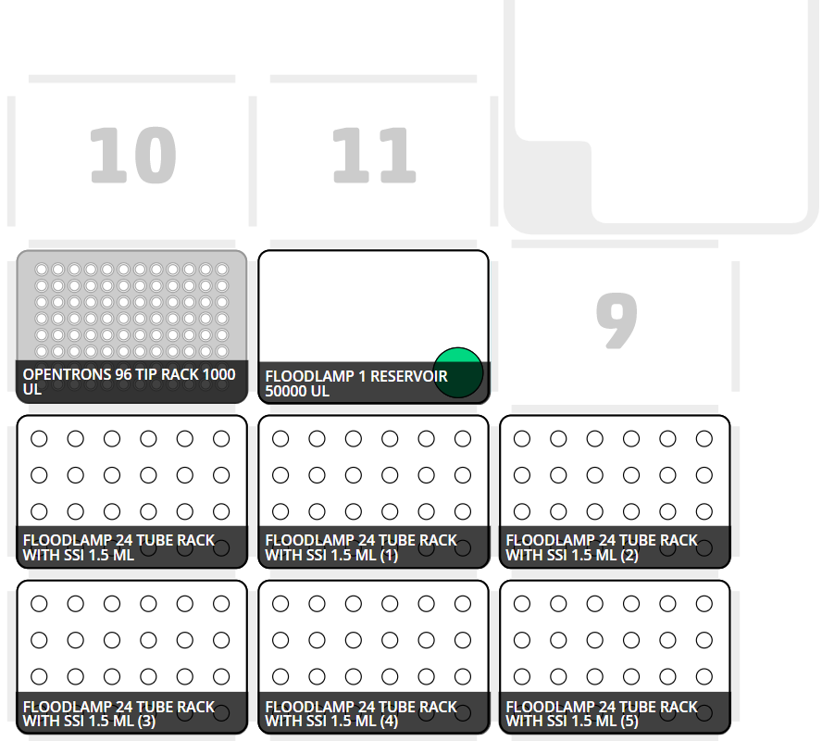

OpenTrons Startup
- Turn on rocker power switch in back left (-- mark).
- Press flashing blue button on front, wait until solid.
- If not already open, launch OpenTrons application with shortcut on desktop, should show .
- Start Hepa unit and put at setpoint.
- Take lid tipbox cover off.
- Ensure tip is in back left position of tipbox.
- Open json protocol.
- Run calibration.
- Leave front panel closed (down) when running.

OpenTrons Shutdown
- Place lid tipbox cover on.
- Turn off Hepa unit.
- Turn off OpenTrons rocker power switch (O mark).
- Close front panel.

